

**HOLIDAY FUNSHEET 3**

**NAME: DATE OF ISSUE:**

**ROLL NO: DATE OF SUBMISSION**

I.IDENTIFY THE ASSOCIATED PICTURE AND CIRCLE IT:

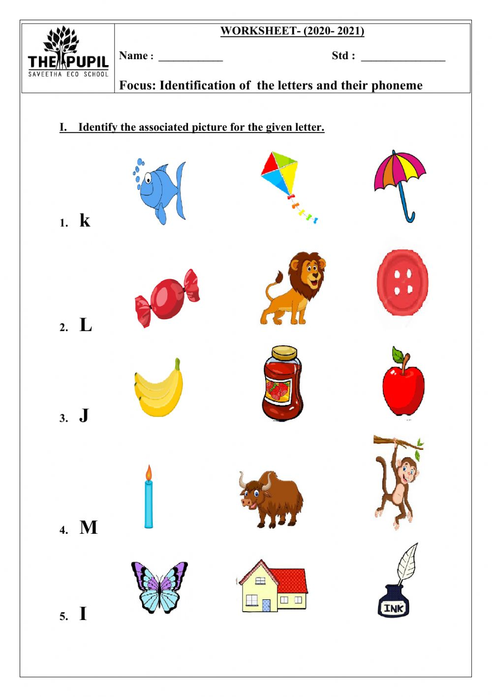

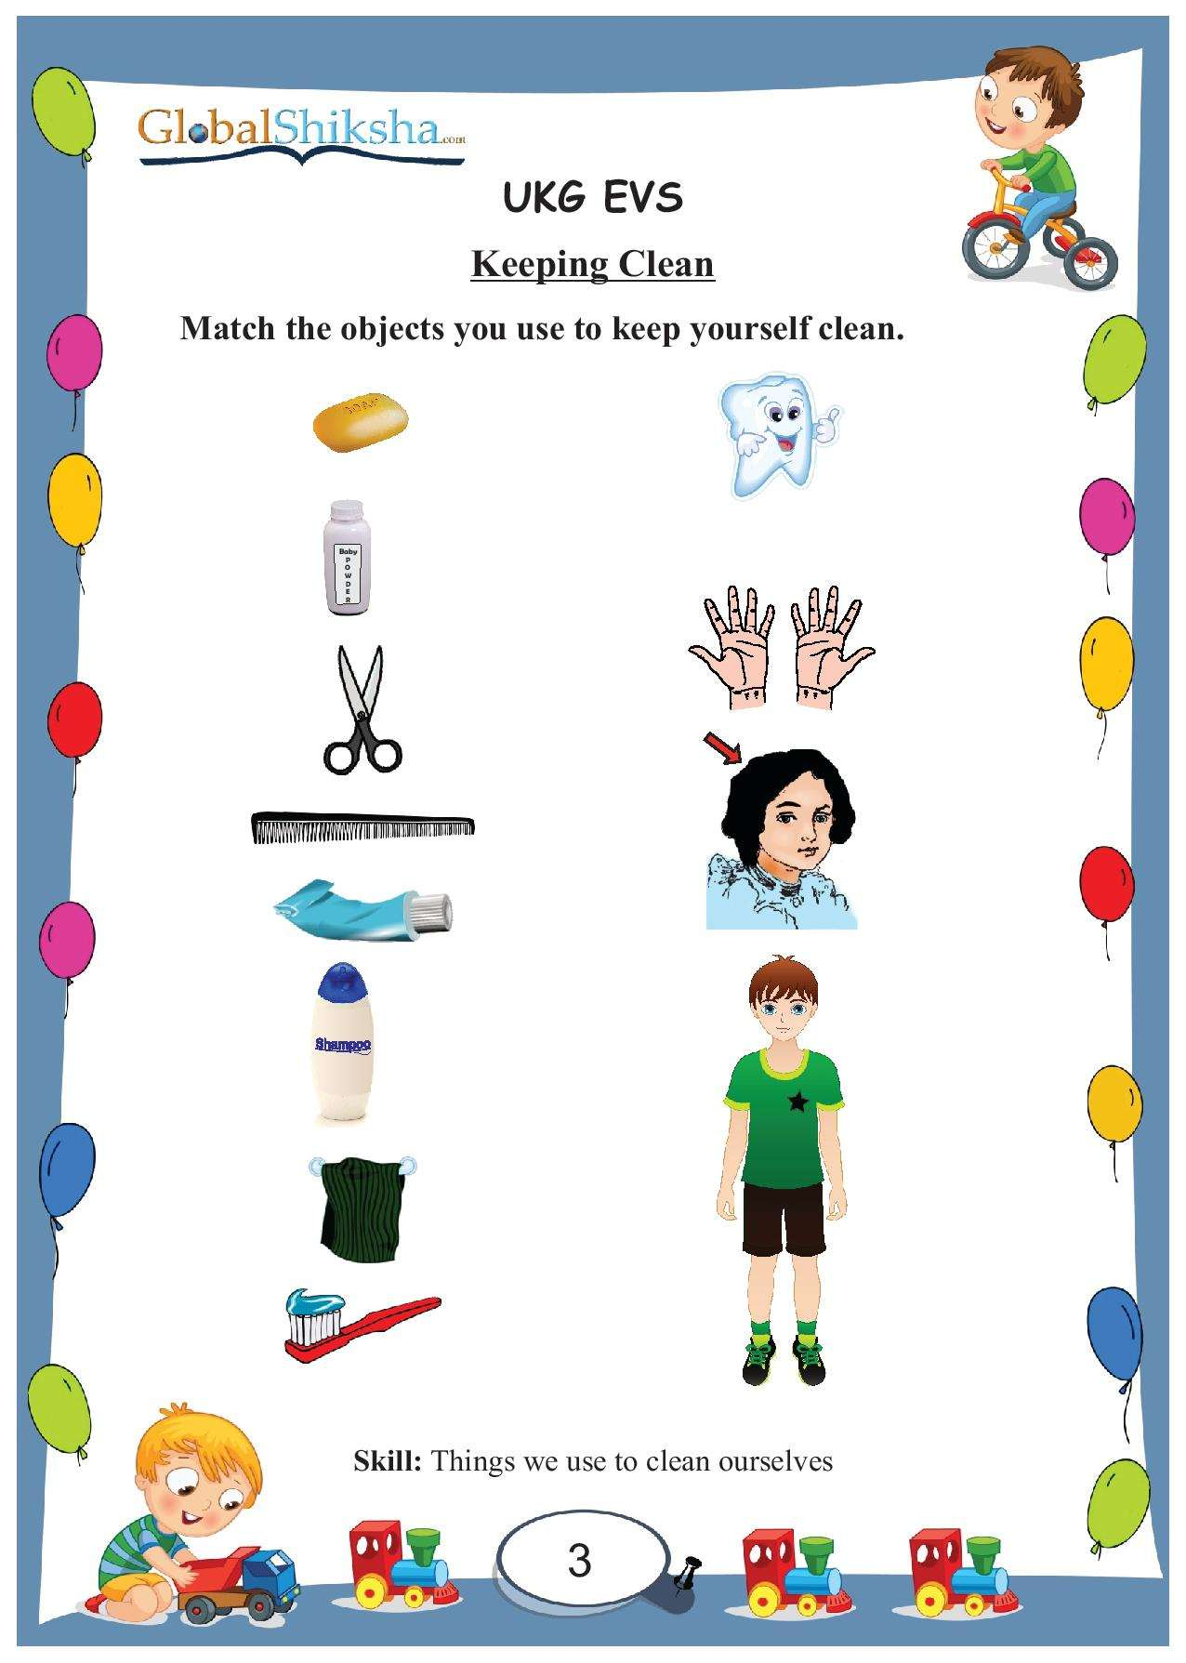

JOIN THE DOTS AND COLOUR THE PICTURE :

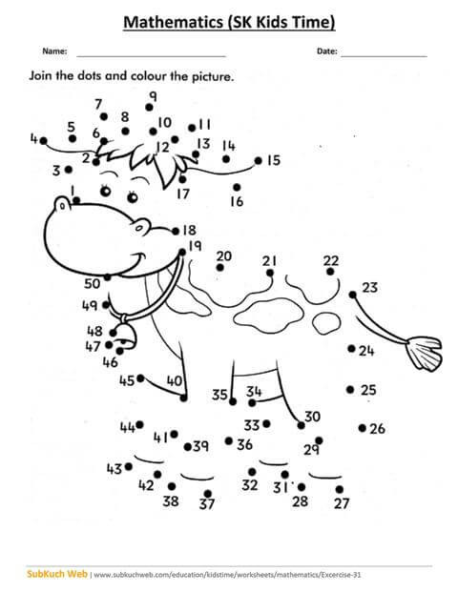

**MAKE A DOLL WITH COLOUR PAPER :**

